**Introduction**

Completed100 XP

* 3 minutes

In this module, you'll learn about the major factors that influence the cost of running in the cloud. Along the way, you'll get hands-on experience with some of the tools you can use to estimate the costs of running your workloads on Azure, to help ensure that you stay within budget and use only the services that you need.

**Meet Tailwind Traders**

[Tailwind Traders](https://www.tailwindtraders.com/) is a fictitious home improvement retailer. It operates retail hardware stores across the globe and online.



Tailwind Traders specializes in competitive pricing, fast shipping, and a large range of items. It's looking at cloud technologies to improve business operations and support growth into new markets. By moving to the cloud, the company plans to enhance its shopping experience to further differentiate itself from competitors.

**How will Tailwind Traders manage cloud costs?**

Tailwind Traders is planning its migration to the cloud. The company has run a few successful proof-of-concept projects, and wants to better understand how to manage its costs before it moves its workloads to Azure.

Running in the datacenter requires you to maintain a facility and purchase, power, cool, and maintain your servers. Running in the cloud presents new ways to think about your IT expenses.

To answer the question of how much it will cost, you need to understand the factors that influence cost. You also need to understand what tools are available to you to help estimate and manage your cloud spend.

**Learning objectives**

After completing this module, you'll be able to:

* Use the Total Cost of Ownership Calculator to compare your current datacenter costs to running the same workloads on Azure
* Describe the different ways you can purchase Azure products and services
* Use the Pricing calculator to estimate the monthly cost of running your cloud workloads
* Define some of the major factors that affect total cost, and apply recommended practices to minimize cost

**Prerequisites**

* You should be familiar with basic computing concepts and terminology
* Familiarity with cloud computing is helpful but isn't necessary

**Next unit: Compare costs by using the Total Cost of Ownership Calculator**

# Compare costs by using the Total Cost of Ownership Calculator

Completed100 XP

* 5 minutes

Before Tailwind Traders takes its next steps toward migrating to the cloud, it wants to better understand what it spends today in its datacenter.

Having a firm understanding of where the company is today will give it a greater sense of what cloud migration means in terms of cost.

In this unit, you'll see how the Total Cost of Ownership (TCO) Calculator can help you compare the cost of running in the datacenter versus running on Azure.

## What's the TCO Calculator?

The [TCO Calculator](https://azure.microsoft.com/pricing/tco/calculator) helps you estimate the cost savings of operating your solution on Azure over time compared to operating in your on-premises datacenter.

The term total cost of ownership is used commonly in finance. It can be hard to see all the hidden costs related to operating a technology capability on-premises. Software licenses and hardware are additional costs.

With the TCO Calculator, you'll enter the details of your on-premises workloads. Then you can review the suggested industry-average cost (which you can adjust) for related operational costs. These costs include electricity, network maintenance, and IT labor. You're then presented with a side-by-side report. Using the report, you can compare those costs with the same workloads running on Azure.

The following image shows one example:

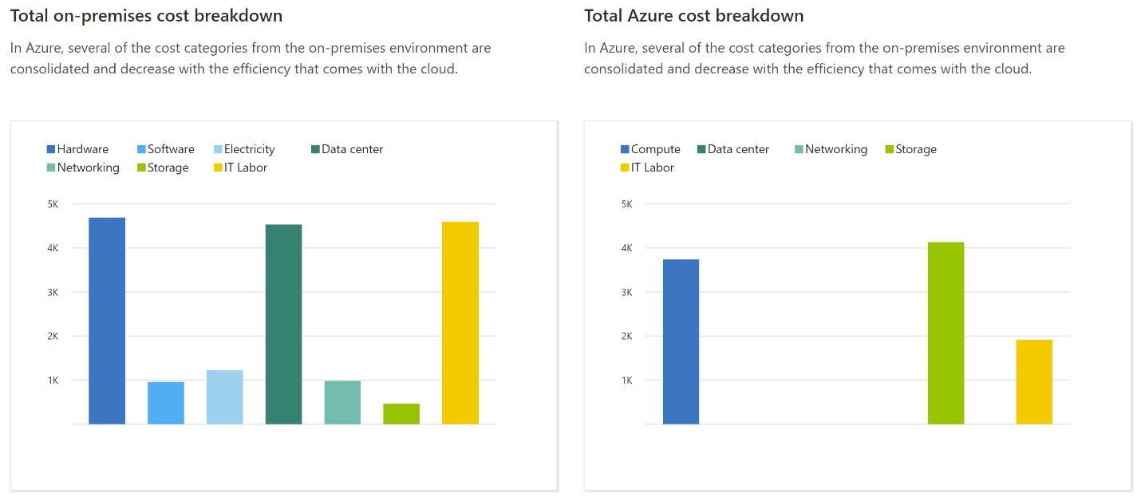

**Note**

You don't need an Azure subscription to work with the TCO Calculator.

## How does the TCO Calculator work?

Working with the TCO Calculator involves three steps:

1. Define your workloads
2. Adjust assumptions
3. View the report

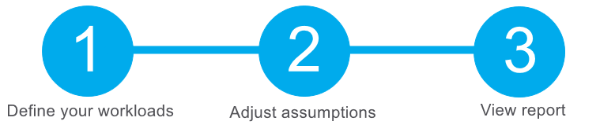

Let's take a closer look at each step.

### Step 1: Define your workloads

First, you'll enter the specifications of your on-premises infrastructure into the TCO Calculator, based on these four categories:

* **Servers**

This category includes operating systems, virtualization methods, CPU cores, and memory (RAM).

* **Databases**

This category includes database types, server hardware, and the Azure service you want to use, which includes the expected maximum concurrent user sign-ins.

* **Storage**

This category includes storage type and capacity, which includes any backup or archive storage.

* **Networking**

This category includes the amount of network bandwidth you currently consume in your on-premises environment.

### Step 2: Adjust assumptions

Next, you'll specify whether your current on-premises licenses are enrolled for [Software Assurance](https://www.microsoft.com/licensing/licensing-programs/software-assurance-default), which can save you money by reusing those licenses on Azure. You'll also specify whether you need to replicate your storage to another Azure region for greater redundancy.

Then, you can see the key operating cost assumptions across several different areas, which will vary among teams and organizations. These costs have been certified by Nucleus Research, an independent research company. For example, these costs include:

* Electricity price per kilowatt hour (KWh)
* Hourly pay rate for IT administration
* Network maintenance cost as a percentage of network hardware and software costs

To improve the accuracy of the TCO Calculator results, you can adjust the values so that they match the costs of your current on-premises infrastructure.

### Step 3: View the report

Choose a timeframe between one and five years. the TCO Calculator generates a report that's based on the information you've entered. Here's an example:

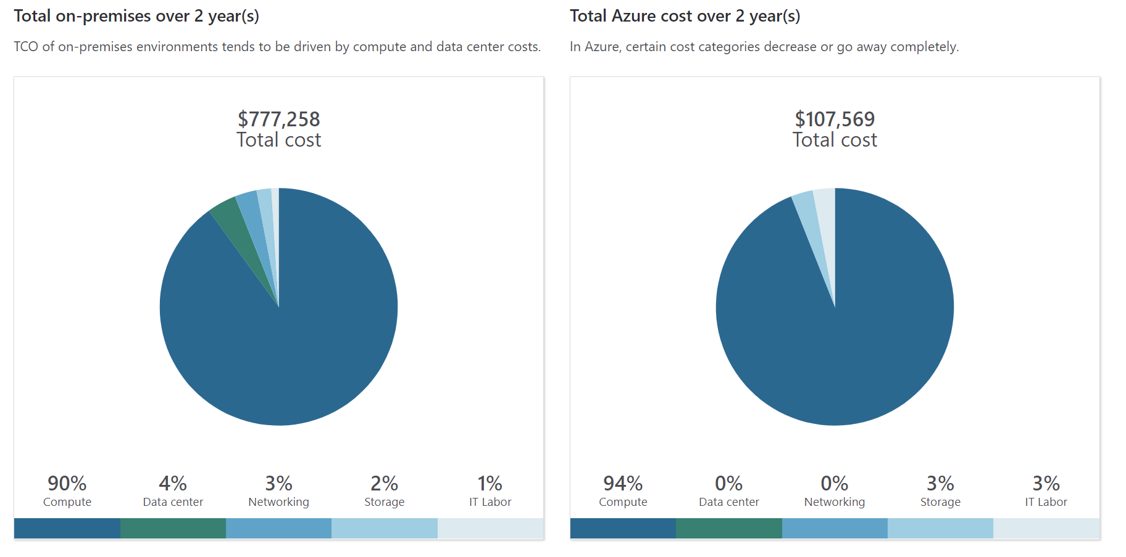

For each category (compute, datacenter, networking, storage, and IT labor), you can also view a side-by-side comparison of the cost breakdown of operating those workloads on-premises versus operating them on Azure. Here's an example:

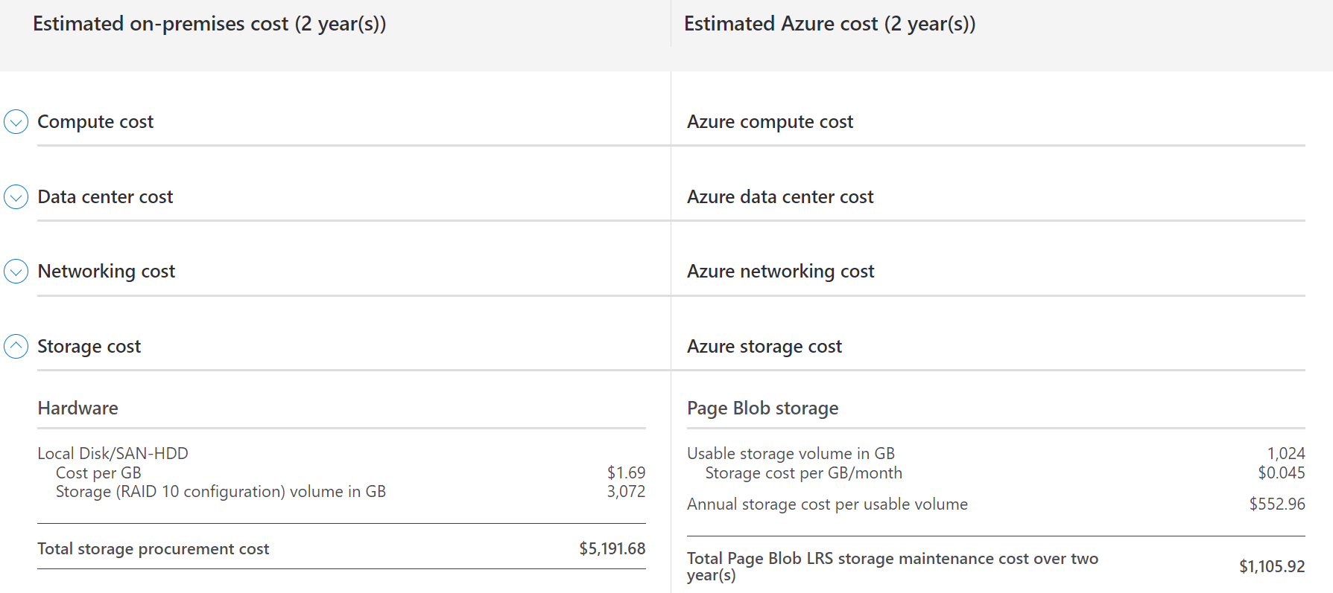

You can download, share, or save this report to review later.

In the next unit, you'll use the TCO Calculator to help the Tailwind Traders team understand their total costs.

## Next unit: Exercise - Compare sample workload costs by using the TCO Calculator

# Compare costs by using the Total Cost of Ownership Calculator

Completed100 XP

* 5 minutes

Before Tailwind Traders takes its next steps toward migrating to the cloud, it wants to better understand what it spends today in its datacenter.

Having a firm understanding of where the company is today will give it a greater sense of what cloud migration means in terms of cost.

In this unit, you'll see how the Total Cost of Ownership (TCO) Calculator can help you compare the cost of running in the datacenter versus running on Azure.

## What's the TCO Calculator?

The [TCO Calculator](https://azure.microsoft.com/pricing/tco/calculator) helps you estimate the cost savings of operating your solution on Azure over time compared to operating in your on-premises datacenter.

The term total cost of ownership is used commonly in finance. It can be hard to see all the hidden costs related to operating a technology capability on-premises. Software licenses and hardware are additional costs.

With the TCO Calculator, you'll enter the details of your on-premises workloads. Then you can review the suggested industry-average cost (which you can adjust) for related operational costs. These costs include electricity, network maintenance, and IT labor. You're then presented with a side-by-side report. Using the report, you can compare those costs with the same workloads running on Azure.

The following image shows one example:



**Note**

You don't need an Azure subscription to work with the TCO Calculator.

## How does the TCO Calculator work?

Working with the TCO Calculator involves three steps:

1. Define your workloads
2. Adjust assumptions
3. View the report



Let's take a closer look at each step.

### Step 1: Define your workloads

First, you'll enter the specifications of your on-premises infrastructure into the TCO Calculator, based on these four categories:

* **Servers**

This category includes operating systems, virtualization methods, CPU cores, and memory (RAM).

* **Databases**

This category includes database types, server hardware, and the Azure service you want to use, which includes the expected maximum concurrent user sign-ins.

* **Storage**

This category includes storage type and capacity, which includes any backup or archive storage.

* **Networking**

This category includes the amount of network bandwidth you currently consume in your on-premises environment.

### Step 2: Adjust assumptions

Next, you'll specify whether your current on-premises licenses are enrolled for [Software Assurance](https://www.microsoft.com/licensing/licensing-programs/software-assurance-default), which can save you money by reusing those licenses on Azure. You'll also specify whether you need to replicate your storage to another Azure region for greater redundancy.

Then, you can see the key operating cost assumptions across several different areas, which will vary among teams and organizations. These costs have been certified by Nucleus Research, an independent research company. For example, these costs include:

* Electricity price per kilowatt hour (KWh)
* Hourly pay rate for IT administration
* Network maintenance cost as a percentage of network hardware and software costs

To improve the accuracy of the TCO Calculator results, you can adjust the values so that they match the costs of your current on-premises infrastructure.

### Step 3: View the report

Choose a timeframe between one and five years. the TCO Calculator generates a report that's based on the information you've entered. Here's an example:



For each category (compute, datacenter, networking, storage, and IT labor), you can also view a side-by-side comparison of the cost breakdown of operating those workloads on-premises versus operating them on Azure. Here's an example:



You can download, share, or save this report to review later.

In the next unit, you'll use the TCO Calculator to help the Tailwind Traders team understand their total costs.

## Next unit: Exercise - Compare sample workload costs by using the TCO Calculator

**Exercise - Compare sample workload costs by using the TCO Calculator**

Completed100 XP

* 6 minutes

In this exercise, you'll use the Total Cost of Ownership (TCO) Calculator to compare the cost of running a sample workload in the datacenter versus on Azure.

Tailwind Traders is interested in moving some of its on-premises workloads to the cloud. But first, the Chief Financial Officer wants to understand more about moving from a relatively fixed-cost structure to an ongoing monthly cost structure.

You've been tasked to investigate whether there are any potential cost savings in moving your European datacenter to the cloud over the next three years. You need to take into account all of the potentially hidden costs involved with operating on-premises and in the cloud.

Instead of manually collecting everything you think might be included, you can use the TCO Calculator as a starting point. You can adjust the provided cost assumptions to match Tailwind Traders' on-premises environment.

**Note**

Remember, you don't need an Azure subscription to work with the TCO Calculator.

Let's say that:

* Tailwind Traders runs two sets, or banks, of 50 virtual machines (VMs) in each bank
* The first bank of VMs runs Windows Server under Hyper-V virtualization
* The second bank of VMs runs Linux under VMware virtualization
* There's also a storage area network (SAN) with 60 terabytes (TB) of disk storage
* You consume an estimated 15 TB of outbound network bandwidth each month
* There are also a number of databases involved, but for now, you'll omit those details

Recall that the TCO Calculator involves three steps:



Let's see how Tailwind Traders' existing workloads compare in the datacenter versus on Azure.

**Define your workloads**

Enter the specifications of your on-premises infrastructure into the TCO Calculator.

1. Go to the [TCO Calculator](https://azure.microsoft.com/pricing/tco/calculator).
2. Under **Define your workloads**, select **Add server workload** to create a row for your bank of Windows Server VMs.
3. Under **Servers**, set the value for each of these settings:

| **Setting** | **Value** |
| --- | --- |
| Name | **Servers: Windows VMs** |
| Workload | **Windows/Linux Server** |
| Environment | **Virtual Machines** |
| Operating system | **Windows** |
| VMs | **50** |
| Virtualization | **Hyper-V** |
| Core(s) | **8** |
| RAM (GB) | **16** |
| Optimize by | **CPU** |
| Windows Server 2008/2008 R2 | **Off** |

1. Select **Add server workload** to create a second row for your bank of Linux VMs. Then specify these settings:

| **Setting** | **Value** |
| --- | --- |
| Name | **Servers: Linux VMs** |
| Workload | **Windows/Linux Server** |
| Environment | **Virtual Machines** |
| Operating system | **Linux** |
| VMs | **50** |
| Virtualization | **VMware** |
| Core(s) | **8** |
| RAM (GB) | **16** |
| Optimize by | **CPU** |

1. Under **Storage**, select **Add storage**. Then specify these settings:

| **Setting** | **Value** |
| --- | --- |
| Name | **Server Storage** |
| Storage type | **Local Disk/SAN** |
| Disk type | **HDD** |
| Capacity | **60 TB** |
| Backup | **120 TB** |
| Archive | **0 TB** |

1. Under **Networking**, set **Outbound bandwidth** to **15 TB**.
2. Select **Next**.

**Adjust assumptions**

Here, you'll specify your currency. For brevity, you can leave the remaining fields at their default values.

In practice, you would adjust any cost assumptions and make any adjustments to match your current on-premises environment.

1. At the top of the page, select your currency. This example uses **US Dollar ($)**.
2. Select **Next**.

**View the report**

Take a moment to review the generated report.

Remember, you've been tasked to investigate cost savings for your European datacenter over the next three years.

To make these adjustments:

1. Set **Timeframe** to **3 Years**.
2. Set **Region** to **North Europe**.

Scroll to the summary at the bottom. You'll see a comparison of running your workloads in the datacenter versus on Azure. The prices you see might differ, but here's an example of the cost savings you might expect.

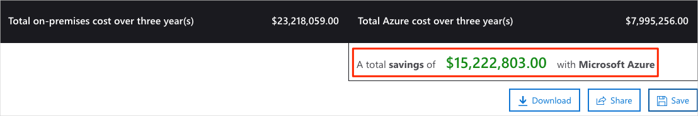

Select **Download** to download or print a copy of the report in PDF format.

Great work. You now have the information that you can share with your Chief Financial Officer. If you need to make adjustments, you can revisit the TCO Calculator to generate a fresh report.

**Next unit: Purchase Azure services**

# Purchase Azure services

Completed100 XP

* 8 minutes

In this unit, you'll learn how to purchase Azure services and get a sense for other factors that affect cost.

You meet with your Chief Financial Officer and some of the team leads and learn about some assumptions you've missed. You were able to quickly update your total estimated spend through the Total Cost of Ownership (TCO) Calculator.

During the meeting, some new questions arose as the discussion moves toward cloud migration:

* What types of Azure subscriptions are available?
* How do we purchase Azure services?
* Does location or network traffic effect cost?
* What other factors affect the final cost?
* How can we get a more detailed estimate of the cost to run on Azure?

It's important to learn how costs are generated in Azure so that you can understand how your purchasing and solution-design decisions can affect your final cost. You've agreed to research these questions, so let's review each one in greater detail.

## What types of Azure subscriptions can I use?

You probably know that an Azure subscription provides you with access to Azure resources such as virtual machines (VMs), storage, and databases. The types of resources you use affect your monthly bill.

Azure offers both free and paid subscription options to fit your needs and requirements. They are:

* **Free trial**

A free trial subscription provides you with 12 months of popular free services, a credit to explore any Azure service for 30 days, and more than 25 services that are always free. Your Azure services are disabled when the trial ends or when your credit expires for paid products, unless you upgrade to a paid subscription.

* **Pay-as-you-go**

A pay-as-you-go subscription lets you pay for what you use by attaching a credit or debit card to your account. Organizations can apply for volume discounts and prepaid invoicing.

* **Member offers**

Your existing membership to certain Microsoft products and services might provide you with credits for your Azure account, and reduced rates on Azure services. For example, member offers are available to Visual Studio subscribers, Microsoft Partner Network members, Microsoft for Startups members, and Microsoft Imagine members.

## How do I purchase Azure services?

There are three main ways to purchase services on Azure. They are:

* **Through an Enterprise Agreement**

Larger customers, known as enterprise customers, can sign an Enterprise Agreement with Microsoft. This agreement commits them to spending a predetermined amount on Azure services over a period of three years. The service fee is typically paid annually. As an Enterprise Agreement customer, you'll receive the best customized pricing based on the kinds and amounts of services you plan on using.

* **Directly from the web**

Here, you can purchase Azure services directly from the Azure portal website and pay standard prices. You're billed monthly, either as a credit card payment or through an invoice. This purchasing method is known as Web Direct.

* **Through a Cloud Solution Provider**

A Cloud Solution Provider (CSP) is a Microsoft Partner that helps you build solutions on top of Azure. Your CSP bills you for your Azure usage at a price they determine. They also answer your support questions and escalate them to Microsoft, as needed.

You can bring up, or provision, Azure resources from the Azure portal or from the command line. The Azure portal arranges products and services by category. You can select the services that fit your needs. Your account is billed according to Azure's "pay for what you use" model.

Here's an example that shows the Azure portal.

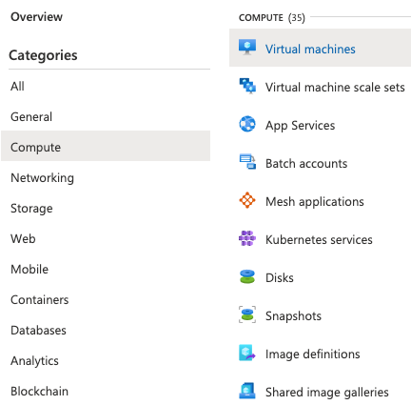

At the end of each month, you're billed for what you've used. At any time, you can check the Cost Management + Billing page in the Azure portal to get a summary of your current usage and review invoices from prior months.

## What factors affect cost?

The way you use resources, your subscription type, and pricing from third-party vendors are common factors. Let's take a quick look at each.

### Resource type

A number of factors influence the cost of Azure resources. They depend on the type of resource or how you customize it.

For example: with a storage account, you'll specify a type (such as block blob storage or table storage), a performance tier (standard or premium), and an access tier (hot, cool, or archive). These selections present different costs.

### Usage meters

When you provision a resource, Azure creates meters to track that resource's usage. Azure uses these meters to generate a usage record that's later used to help calculate your bill.

Think of usage meters as similar to how you use electricity or water in your home. You might pay a base price each month for electricity or water service, but your final bill is based on the total amount that you consumed.

Let's look at a single VM as an example. The following kinds of meters are relevant to tracking its usage:

* Overall CPU time
* Time spent with a public IP address
* Incoming (ingress) and outgoing (egress) network traffic in and out of the VM
* Disk size and amount of disk read and disk write operations

Each meter tracks a specific type of usage. For example, a meter might track bandwidth usage (ingress or egress network traffic in bits per second), number of operations, or its size (storage capacity in bytes).

The usage that a meter tracks correlates to a quantity of billable units. Those units are charged to your account for each billing period. The rate per billable unit depends on the resource type you're using.

### Resource usage

In Azure, you're always charged based on what you use. As an example, let's look at how this billing applies to deallocating a VM.

In Azure, you can delete or deallocate a VM. Deleting a VM means that you no longer need it. The VM is removed from your subscription, then it's prepared for another customer.

Deallocating a VM means that the VM is no longer running, but the associated hard disks and data are still kept in Azure. The VM isn't assigned to a CPU or network in Azure's datacenter, so it doesn't generate the costs associated with compute time or the VM's IP address. Because the disks and data are still stored, and the resource is present in your Azure subscription, you're still billed for disk storage.

Deallocating a VM when you don't plan on using it for some time is just one way to minimize costs. For example, you might deallocate the VMs you use for testing purposes on weekends when your testing team isn't using them. You'll learn more about ways to minimize cost later in this module.

### Azure subscription types

Some Azure subscription types also include usage allowances, which affect costs.

For example, an Azure free trial subscription provides access to a number of Azure products that are free for 12 months. It also includes credit to spend within your first 30 days of sign-up. You also get access to more than 25 products that are always free (based on resource and region availability).

### Azure Marketplace

You can also purchase Azure-based solutions and services from third-party vendors through Azure Marketplace. Examples include managed network firewall appliances or connectors to third-party backup services. Billing structures are set by the vendor.

## Does location or network traffic affect cost?

When you provision a resource in Azure, you need to define the location (known as the Azure region) of where it will be deployed. Let's see why this decision can have cost consequences.

### Location

Azure infrastructure is distributed globally, which lets you deploy your services centrally or provision your services closest to where your customers use them.

Different regions can have different associated prices. Because geographic regions can affect where your network traffic flows, network traffic is a cost influence to consider as well.

For example, say Tailwind Traders decides to provision its Azure resources in the Azure regions that offer the lowest prices. That decision would save the company some money. However, if they need to transfer data between those regions, or if their users are located in different parts of the world, any potential savings could be offset by the additional network-usage costs of transferring data between those resources.

### Zones for billing of network traffic

Billing zones are a factor in determining the cost of some Azure services.

[Bandwidth](https://azure.microsoft.com/pricing/details/bandwidth) refers to data moving in and out of Azure datacenters. Some inbound data transfers (data going into Azure datacenters) are free. For outbound data transfers (data leaving Azure datacenters), data transfer pricing is based on zones.



A zone is a geographical grouping of Azure regions for billing purposes. The following zones include some of the regions as shown here:

* **Zone 1**: Australia Central, West US, East US, Canada West, West Europe, France Central, and others
* **Zone 2**: Australia East, Japan West, Central India, Korea South, and others
* **Zone 3**: Brazil South, South Africa North, South Africa West, UAE Central, UAE North
* **DE Zone 1**: Germany Central, Germany Northeast

## How can I estimate the total cost?

## <https://learn.microsoft.com/en-us/training/modules/plan-manage-azure-costs/4-purchase-azure-services>

As you've learned, an accurate cost estimate takes all of the preceding factors into account. Fortunately, the Azure Pricing calculator helps you with that process.

The Pricing calculator displays Azure products in categories. You can add these categories to your estimate and configure according to your specific requirements. You'll then receive a consolidated estimated price, with a detailed breakdown of the costs associated with each resource you added to your solution. You can export or share that estimate or save it for later. You can load a saved estimate and modify it to match updated requirements.

You also can access pricing details, product details, and documentation for each product from within the Pricing calculator.

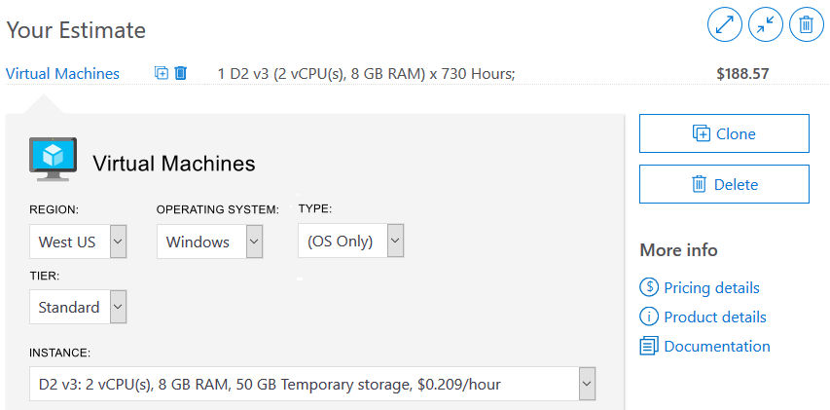

The options you can configure in the Pricing calculator vary between products, but can include:

* **Region**

A region is the geographical location in which you can provision a service. Southeast Asia, Central Canada, Western United States, and Northern Europe are a few examples.

* **Tier**

Tiers, such as the Free tier or Basic tier, have different levels of availability or performance and different associated costs.

* **Billing options**

Billing options highlight the different ways you can pay for a service. Options can vary based on your customer type and subscription type, and can include options to save costs.

* **Support options**

These options let you select additional support pricing options for certain services.

* **Programs and offers**

Your customer or subscription type might allow you to choose from specific licensing programs or other offers.

* **Azure Dev/Test pricing**

This option lists the available prices for development and test workloads. Dev/Test pricing applies when you run resources within an Azure subscription that's based on a Dev/Test offer.

Keep in mind that the Pricing calculator provides estimates and not actual price quotes. Actual prices can vary depending upon the date of purchase, the payment currency you're using, and the type of Azure customer you are.

## Next unit: Exercise - Estimate workload cost by using the Pricing calculator

# Exercise - Estimate workload cost by using the Pricing calculator

Completed100 XP

* 6 minutes

In this exercise, you'll use the Pricing calculator to estimate the cost of running a basic web application on Azure.

With an understanding of the more important cost factors associated with running on Azure, Tailwind Traders wants to take a typical workload and estimate how much it would cost each month to run it on Azure.

The IT Manager at Tailwind Traders is faced with the decision about whether to replace some aging on-premises hardware or move the application to Azure. The company needs to know how much the ongoing monthly cost of the solution in Azure would be.

Let's start by defining which Azure services you need.

**Note**

The Pricing calculator is for information purposes only. The prices are only an estimate, and you won't be charged for any services you select.

## Define your requirements

Before you run the Pricing calculator, you first need a sense of what Azure services you need.

You've met with the application development team to discuss their migration project. In their datacenter, the team has an ASP.NET web application that runs on Windows. The web application provides information about product inventory and pricing. They have two virtual machines that are connected through a central load balancer. The web application connects to a SQL Server database that holds inventory and pricing information.

The team decides to:

* Use Azure Virtual Machines instances, similar to the virtual machines they use in the datacenter
* Use Azure Application Gateway for load balancing
* Use Azure SQL Database to hold inventory and pricing information

Here's a diagram that shows the basic configuration:

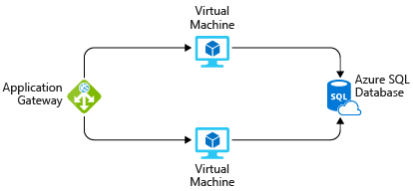

In practice, you would define your requirements in greater detail. But here are some basic facts and requirements that came up during the meeting:

* Tailwind Traders employees use the application at their retail stores. It's not accessible to customers.
* This application doesn't require a massive amount of computing power.
* The virtual machines and the database run all the time (730 hours per month).
* The network processes about 1 TB of data per month.
* The database doesn't need to be configured for high-performance workloads and requires no more than 32 GB of storage.

## Explore the Pricing calculator

Let's start with a quick tour of the Pricing calculator.

1. Go to the [Pricing calculator](https://azure.microsoft.com/pricing/calculator/).
2. Notice the following tabs:

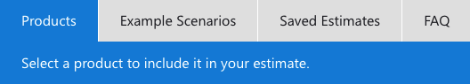

* + **Products**

This is where you can choose the Azure services that you want to include in your estimate. You'll likely spend most of your time here.

* + **Example Scenarios**

Here you'll find several reference architectures, or common cloud-based solutions that you can use as a starting point.

* + **Saved Estimates**

Here you'll find your previously saved estimates.

* + **FAQ**

Here you'll discover answers to frequently asked questions about the Pricing calculator.

## Estimate your solution

Here you'll add each Azure service that you need to the calculator. Then you configure each service to fit your needs.

**Tip**

Make sure you have a clean calculator with nothing listed in the estimate. You can reset the estimate by selecting the trash can icon next to each item.

### Add services to the estimate

1. On the **Products** tab, select the service from each of these categories:

| **Category** | **Service** |
| --- | --- |
| Compute | **Virtual Machines** |
| Databases | **Azure SQL Database** |
| Networking | **Application Gateway** |

1. Scroll to the bottom of the page. You'll see that each service is listed with its default configuration.

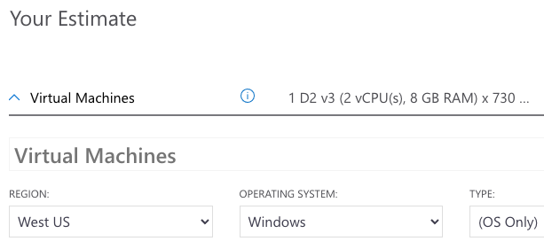

### Configure services to match your requirements

1. Under **Virtual Machines**, set these values:

| **Setting** | **Value** |
| --- | --- |
| Region | **West US** |
| Operating system | **Windows** |
| Type | **(OS Only)** |
| Tier | **Standard** |
| Instance | **D2 v3** |
| Virtual machines | **2** x **730 Hours** |

1. Leave the remaining settings at their current values.
2. Under **Azure SQL Database**, set these values:

| **Setting** | **Value** |
| --- | --- |
| Region | **West US** |
| Type | **Single Database** |
| Backup storage tier | **RA-GRS** |
| Purchase model | **vCore** |
| Service tier | **General Purpose** |
| Compute tier | **Provisioned** |
| Generation | **Gen 5** |
| Instance | **8 vCore** |

1. Leave the remaining settings at their current values.
2. Under **Application Gateway**, set these values:

| **Setting** | **Value** |
| --- | --- |
| Region | **West US** |
| Tier | **Web Application Firewall** |
| Size | **Medium** |
| Gateway hours | **2** x **730 Hours** |
| Data processed | **1 TB** |
| Outbound data transfer | **5 GB** |

1. Leave the remaining settings at their current values.

## Review, share, and save your estimate

At the bottom of the page, you'll see the total estimated cost of running the solution. You can change the currency type if you want.

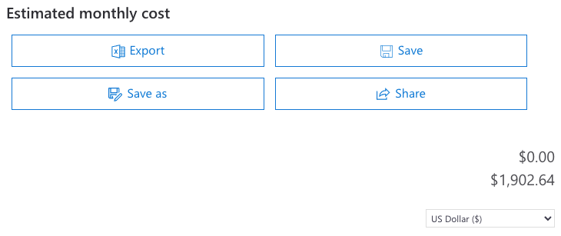

At this point, you have a few options:

* Select **Export** to save your estimate as an Excel document
* Select **Save** or **Save as** to save your estimate to the **Saved Estimates** tab for later
* Select **Share** to generate a URL so you can share the estimate with your team

You now have a cost estimate that you can share with your team. You can make adjustments as you discover any changes to your requirements.

Experiment with some of the options you worked with here, or create a purchase plan for a workload you want to run on Azure.

## Next unit: Manage and minimize total cost on Azure

# Manage and minimize total cost on Azure

Completed100 XP

* 11 minutes

As a home improvement retailer, the proverb "measure twice, cut once" is fitting for the team at Tailwind Traders.

Here are some recommended practices that can help you minimize your costs.

## Understand estimated costs before you deploy

To help you plan your solution on Azure, carefully consider the products, services, and resources you need. Read the relevant documentation to understand how each of your choices is metered and billed.

Calculate your projected costs by using the Pricing calculator and the Total Cost of Ownership (TCO) Calculator. Only add the products, services, and resources that you need for your solution.

## Use Azure Advisor to monitor your usage

Ideally, you want your provisioned resources to match your actual usage.

Azure Advisor identifies unused or underutilized resources and recommends unused resources that you can remove. This information helps you configure your resources to match your actual workload.

The following image shows some example recommendations from Azure Advisor:

[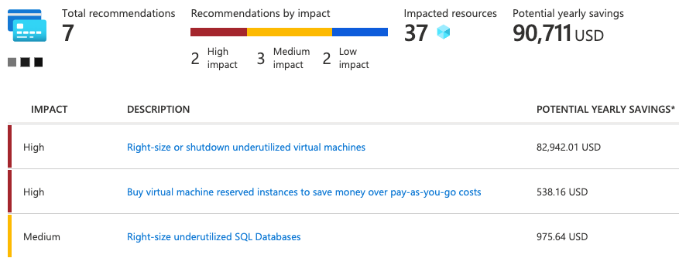](https://learn.microsoft.com/en-us/training/azure-fundamentals/plan-manage-azure-costs/media/6-azure-advisor-expanded.png#lightbox)

Recommendations are sorted by impact: high, medium, or low. In some cases, Azure Advisor can automatically remediate, or fix, the underlying problem. Other issues, such as the two that are listed as high impact, require human intervention.

## Use spending limits to restrict your spending

If you have a free trial or a credit-based Azure subscription, you can use spending limits to prevent accidental overrun.

For example, when you spend all the credit included with your Azure free account, Azure resources that you deployed are removed from production and your Azure virtual machines (VMs) are stopped and deallocated. The data in your storage accounts is available as read-only. At this point, you can upgrade your free trial subscription to a pay-as-you-go subscription.

If you have a credit-based subscription and you reach your configured spending limit, Azure suspends your subscription until a new billing period begins.

A related concept is quotas, or limits on the number of similar resources you can provision within your subscription. For example, you can allocate up to 25,000 VMs per region. These limits mainly help Microsoft plan its datacenter capacity.

## Use Azure Reservations to prepay

Azure Reservations offers discounted prices on certain Azure services. Azure Reservations can save you up to 72 percent as compared to pay-as-you-go prices. To receive a discount, you can reserve services and resources by paying in advance.

For example, you can prepay for one year or three years of use of VMs, database compute capacity, database throughput, and other Azure resources.

The following example shows estimated savings on VMs. In this example, you save an estimated 72 percent by committing to a three-year term.

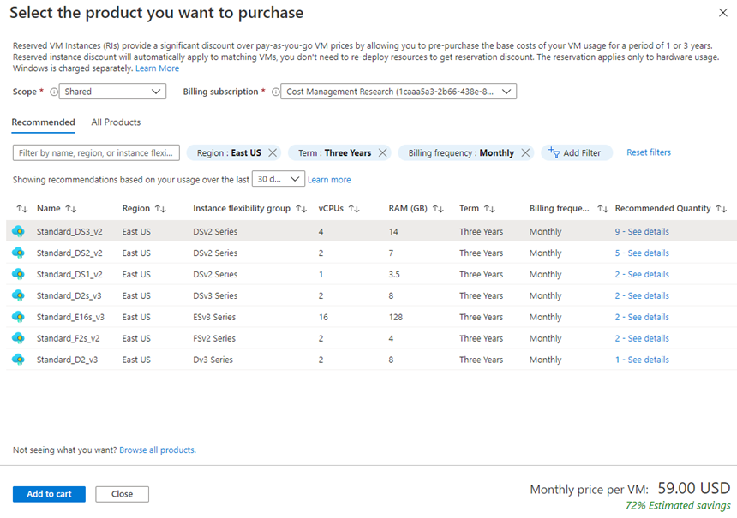

Azure Reservations are available to customers with an Enterprise Agreement, Cloud Solution Providers, and pay-as-you-go subscriptions.

## Choose low-cost locations and regions

The cost of Azure products, services, and resources can vary across locations and regions. If possible, you should use them in those locations and regions where they cost less.

But remember, some resources are metered and billed according to how much outgoing (egress) network bandwidth they consume. You should provision connected resources that are metered by bandwidth in the same Azure region to reduce egress traffic between them.

## Research available cost-saving offers

Keep up to date with the latest Azure customer and subscription offers, and switch to offers that provide the greatest cost-saving benefit.

## Use Microsoft Cost Management + Billing to control spending

Cost Management is a free service that helps you understand your Azure bill, manage your account and subscriptions, monitor and control Azure spending, and optimize resource use.

The following image shows current usage broken down by service:

[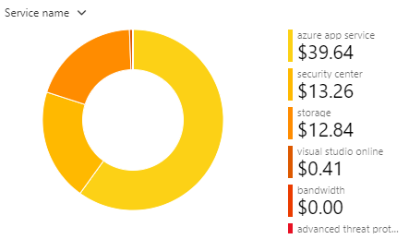](https://learn.microsoft.com/en-us/training/azure-fundamentals/plan-manage-azure-costs/media/6-cost-management-expanded.png#lightbox)

In this example, Azure App Service, a web application hosting service, generates the greatest cost.

Cost Management features include:

* **Reporting**

Use historical data to generate reports and forecast future usage and expenditure.

* **Data enrichment**

Improve accountability by categorizing resources with tags that correspond to real-world business and organizational units.

* **Budgets**

Create and manage cost and usage budgets by monitoring resource demand trends, consumption rates, and cost patterns.

* **Alerting**

Get alerts based on your cost and usage budgets.

* **Recommendations**

Receive recommendations to eliminate idle resources and to optimize the Azure resources you provision.

## Apply tags to identify cost owners

Tags help you manage costs associated with the different groups of Azure products and resources. You can apply tags to groups of Azure resources to organize billing data.

For example, if you run several VMs for different teams, you can use tags to categorize costs by department, such as Human Resources, Marketing, or Finance; or by environment, such as Test or Production.

Tags make it easier to identify groups that generate the biggest Azure costs, which can help you adjust your spending accordingly.

The following image shows a year's worth of usage broken down by tags on the Cost Management page:

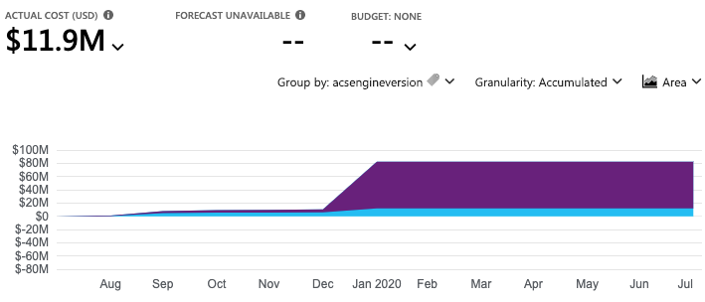

## Resize underutilized virtual machines

A common recommendation that you'll find from Cost Management and Azure Advisor is to resize or shut down VMs that are underutilized or idle.

As an example, say you have a VM whose size is **Standard_D4_v4**, a general-purpose VM type with four vCPUs and 16 GB of memory. You might discover that this VM is idle 90 percent of the time.

Virtual machine costs are linear and double for each size larger in the same series. So in this case, if you reduce the VM's size from **Standard_D4_v4** to **Standard_D2_v4**, which is the next size lower, you reduce your compute cost by 50 percent.

The following image shows this idea:

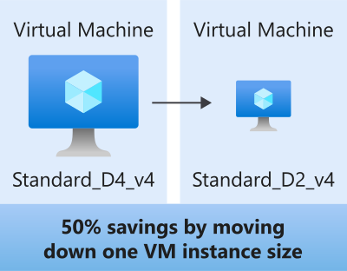

Keep in mind that resizing a VM requires it to be stopped, resized, and then restarted. This process might take a few minutes depending on how significant the size change is. Be sure to properly plan for an outage, or shift your traffic to another instance while you perform resize operations.

## Deallocate virtual machines during off hours

Recall that to deallocate a VM means to no longer run the VM, but preserve the associated hard disks and data in Azure.

If you have VM workloads that are only used during certain periods, but you're running them every hour of every day, you're wasting money. These VMs are great candidates to shut down when not in use and start back when you need them, saving you compute costs while the VM is deallocated.

This approach is an excellent strategy for development and testing environments, where the VMs are needed only during business hours. Azure even provides a way to automatically start and stop your VMs on a schedule.

## Delete unused resources

This recommendation might sound obvious, but if you aren't using a resource, you should shut it down. It's not uncommon to find nonproduction or proof-of-concept systems that are no longer needed following the completion of a project.

Regularly review your environment, and work to identify these systems. Shutting down these systems can have a dual benefit by saving you on infrastructure costs and potential savings on licensing and operating costs.

## Migrate from IaaS to PaaS services

As you move your workloads to the cloud, a natural evolution is to start with infrastructure as a service (IaaS) services, because they map more directly to concepts and operations you're already familiar with.

Over time, one way to reduce costs is to gradually move IaaS workloads to run on platform as a service (PaaS) services. While you can think of IaaS as direct access to compute infrastructure, PaaS provides ready-made development and deployment environments that are managed for you.

As an example, say you run SQL Server on a VM running on Azure. This configuration requires you to manage the underlying operating system, set up a SQL Server license, manage software and security updates, and so on. You also pay for the VM whether or not the database is processing queries. One way to potentially save costs is to move your database from SQL Server on a VM to Azure SQL Database. Azure SQL Database is based on SQL Server.

Not only are PaaS services such as Azure SQL Database often less expensive to run, but because they're managed for you, you don't need to worry about software updates, security patches, or optimizing physical storage for read and write operations.

## Save on licensing costs

Licensing is another area that can dramatically affect your cloud spending. Let's look at some ways you can reduce your licensing costs.

### Choose cost-effective operating systems

Many Azure services provide a choice of running on Windows or Linux. In some cases, the cost depends on which you choose. When you have a choice, and your application doesn't depend on the underlying operating system, it's useful to compare pricing to see whether you can save money.

### Use Azure Hybrid Benefit to repurpose software licenses on Azure

If you've purchased licenses for Windows Server or SQL Server, and your licenses are covered by [Software Assurance](https://www.microsoft.com/licensing/licensing-programs/software-assurance-default), you might be able to repurpose those licenses on VMs on Azure.

Some of the details vary between Windows Server or SQL Server. We'll provide resources for you to learn more at the end of this module.

## Next unit: Knowledge check

**Knowledge check**

Completed200 XP

* 2 minutes

Consider the following scenario, then choose the best response for each question that follows, and select **Check your answers**.

Before they migrate their existing e-commerce system from their datacenter to production environments on Azure, the Tailwind Traders team wants to first set up environments for development and testing.

Here's a diagram that shows the basic compute, database, and networking components found in each environment:

An e-commerce system might require a website, the products database, a payment system, and so on. Because developers can't always run the entire service from their local development environment, the *Dev* environment is the first place where everything the app needs comes together.

After the development team verifies changes to the Dev environment, they promote changes to the Test environment. The Test environment is where the testing team verifies new app features and also verifies that no *regressions*, or breaks to existing features, happen as new features are added.

The team will map each component in their existing infrastructure to the appropriate Azure service.

**Check your knowledge**

Top of Form

**1.**

Which is the best first step the team should take to compare the cost of running these environments on Azure versus in their datacenter?



They're just test environments. Spin them up and check the bill at the end of the month.



Assume that running in the cloud costs about the same as running in the datacenter.



Run the Total Cost of Ownership Calculator.

**Running the Total Cost of Ownership Calculator is a great first step because it can provide an accurate comparison of running workloads in the datacenter versus on Azure, certified by an independent research company.**

**2.**

What's the best way to ensure that the development team doesn't provision too many virtual machines at the same time?



Do nothing. Let the development team use what they need.



Apply spending limits to the development team's Azure subscription.

**If you exceed your spending limit, active resources are deallocated. You can then decide whether to increase your limit or provision fewer resources.**



Verbally give the development lead a budget and hold them accountable for overages.

**3.**

Which is the most efficient way for the testing team to save costs on virtual machines on weekends, when testers are not at work?



Delete the virtual machines before the weekend and create a new set the following week.



Deallocate virtual machines when they're not in use.

**When you deallocate virtual machines, the associated hard disks and data are still kept in Azure. But you don't pay for CPU or network consumption, which can help save costs.**



Just let everything run. Azure bills you only for the CPU time that you use.

**4.**

Resources in the Dev and Test environments are each paid for by different departments. What's the best way to categorize costs by department?



Apply a tag to each virtual machine that identifies the appropriate billing department.

**You can apply tags to groups of Azure resources to organize billing data.**



Split the cost evenly between departments.



Keep a spreadsheet that lists each team's resources.

Bottom of Form

**Next unit: Summary**

# Summary

Completed100 XP

* 2 minutes

Tailwind Traders is taking a methodical approach toward cloud migration. While proof-of-concept projects can help demonstrate technical feasibility, having a clear picture of the total cost of running in the cloud will further help the team validate its approach.

To start, the Tailwind Traders team used the Total Cost of Ownership Calculator to estimate the cost savings of operating its solution on Azure instead of in its on-premises datacenter.

From there, the team used the Pricing calculator to get a more detailed estimate for running a typical workload on Azure each month.

The team also created a checklist of cost-saving measures that it can use to help keep down costs. This list includes:

* Perform cost analysis before you deploy
* Use Azure Advisor to monitor your usage
* Use spending limits to prevent accidental spending
* Use Azure Reservations to prepay
* Choose low-cost locations and regions
* Research available cost-saving offers
* Apply tags to identify cost owners

With these measures in place, the Tailwind Traders team is ready to take the next steps toward cloud migration.

## Next steps

If you run existing workloads on-premises or in the datacenter, try entering your existing workloads in the [Total Cost of Ownership Calculator](https://azure.microsoft.com/pricing/tco) to see how the cost of running on Azure compares to what you pay today.

Then, use the [Azure documentation](https://learn.microsoft.com/en-us/azure/) to map your current infrastructure to cloud services. Use the [Pricing calculator](https://azure.microsoft.com/pricing/calculator/) to get a more accurate picture of what it would cost to run your existing workloads on Azure.

## Learn more

In this module, you learned about the many factors that affect the total cost of running on Azure.

The [Control Azure spending and manage bills with Microsoft Cost Management](https://learn.microsoft.com/en-us/training/paths/control-spending-manage-bills/) learning path is a great next step toward learning how to monitor and control your Azure spending.

Here are additional resources to help you go further.

### Purchase Azure services

* If you're just getting started with Azure, review commonly asked questions in the [Azure free account FAQ](https://azure.microsoft.com/free/free-account-faq/) to see whether a free trial account is right for you.
* To learn more about how to purchase Azure products and services, see [Explore flexible purchasing options for Azure](https://azure.microsoft.com/pricing/purchase-options).

### Understand your bill

* For more information about Azure usage charges, see [Understand terms on your Microsoft Azure invoice](https://learn.microsoft.com/en-us/azure/billing/billing-understand-your-invoice).
* To learn more about how bandwidth affects pricing, see [Bandwidth pricing details](https://azure.microsoft.com/pricing/details/bandwidth).

### Manage and minimize costs

* See [Microsoft Cost Management](https://azure.microsoft.com/services/cost-management) to learn more about analyzing costs, creating and managing budgets, exporting data, and reviewing and acting on recommendations.
* Take advantage of significant discounts on development and testing workloads. To learn more, see [Azure Dev/Test pricing](https://azure.microsoft.com/pricing/dev-test/).
* Learn more about how [Azure Reservations](https://learn.microsoft.com/en-us/azure/billing/billing-save-compute-costs-reservations) can save you money when you commit to one-year or three-year pricing plans.
* Learn how to [prevent unexpected charges with Microsoft Cost Management](https://learn.microsoft.com/en-us/azure/cost-management-billing/manage/getting-started).
* See [Azure spending limit](https://learn.microsoft.com/en-us/azure/billing/billing-spending-limit) to learn what happens when you reach your spending limit and how to remove it.
* Learn how to [start and stop VMs during off-hours](https://learn.microsoft.com/en-us/azure/automation/automation-solution-vm-management).
* See how [Azure Hybrid Benefit](https://azure.microsoft.com/pricing/hybrid-benefit/) can help save costs by bringing Windows Server and SQL Server on-premises licenses with Software Assurance to Azure.

## Module complete: